深 圳 大 学 实 验 报 告

课程名称： Database System

实验项目名称： Data Modelling using PowerDesigner

学院： Computer Science and Software Engineering

专业： Software Engineering

指导教师： Basker George

报告人___沈晨玙__学号：2019092121班级：_19级国际班___

实验时间： 2020.12.10

实验报告提交时间： 2020.12.10

教务部制
实验目的与要求：(Purpose of Experiment purpose and Requirements)
* Please show all work for these problems.
Just writing down the answer will not get full credit.

Transform the following ER diagram into Relations and Create the required tables using Oracle / MySQL: (with Primary Key, Foreign Key if any, Data types, Width, Domain and Integrity Constraints )

EER diagram 1):

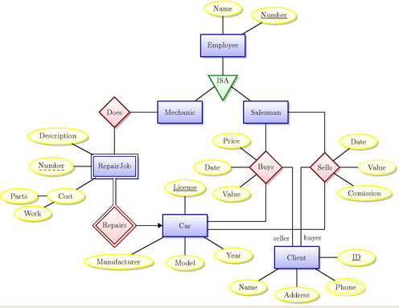
Identify the following
- Identify the type of relationship (1:1, 1:m, m:m)
1:1
Employee:Mechanic
Employee:Salesman
1:m
Car:RepairJob
Salesman:Cars
Client:Cars
M:m
Mechanic:RepairJob
Salesman:Client

- Identify the cardinality (Min, Max)
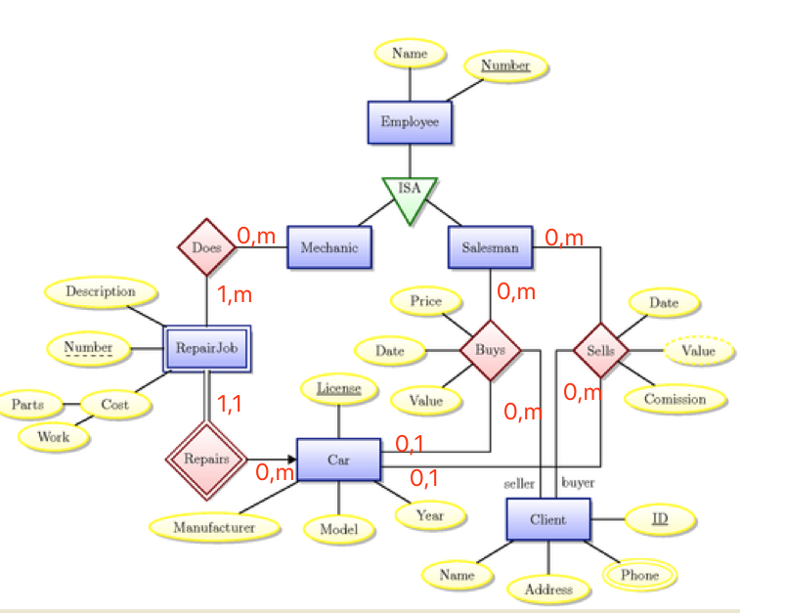
- Primary Key
Table Employee: Number
Table Repair: Number
Table Cars: License
Table Client: ID
Table Buys: SalesmanNumber, License, ID
Table Sells: SalesmanNumber, License, ID
Table Employee: Number
Table Mechanic: MechanicNumber
Table Salesman: SalesmanNumber

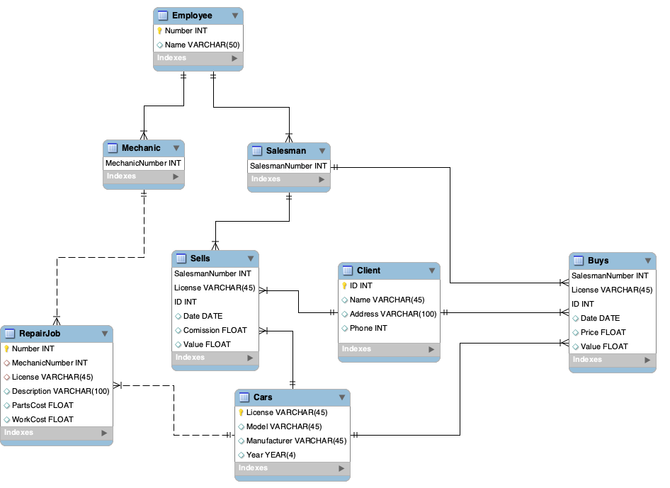
SQL：
-- -----------------------------------------------------
-- Schema CarSales
-- -----------------------------------------------------
CREATE SCHEMA IF NOT EXISTS `CarSales` DEFAULT CHARACTER SET utf8 ;
USE `CarSales` ;

-- -----------------------------------------------------
-- Table `CarSales`.`Employee`
-- -----------------------------------------------------
CREATE TABLE IF NOT EXISTS `CarSales`.`Employee` (
`Number` INT NOT NULL,
`Name` VARCHAR(50) NULL,
PRIMARY KEY (`Number`))
ENGINE = InnoDB;

-- -----------------------------------------------------
-- Table `CarSales`.`Mechanic`
-- -----------------------------------------------------
CREATE TABLE IF NOT EXISTS `CarSales`.`Mechanic` (
`MechanicNumber` INT NOT NULL,
PRIMARY KEY (`MechanicNumber`),
CONSTRAINT `fk_Mechanic_Employee`
FOREIGN KEY (`MechanicNumber`)
REFERENCES `CarSales`.`Employee` (`Number`))
;

-- -----------------------------------------------------
-- Table `CarSales`.`Salesman`
-- -----------------------------------------------------
CREATE TABLE IF NOT EXISTS `CarSales`.`Salesman` (
`SalesmanNumber` INT NOT NULL,
PRIMARY KEY (`SalesmanNumber`),
CONSTRAINT `fk_Salesman_Employee1`
FOREIGN KEY (`SalesmanNumber`)
REFERENCES `CarSales`.`Employee` (`Number`));

-- -----------------------------------------------------
-- Table `CarSales`.`Cars`
-- -----------------------------------------------------
CREATE TABLE IF NOT EXISTS `CarSales`.`Cars` (
`License` VARCHAR(45) NOT NULL,
`Model` VARCHAR(45) NULL,
`Manufacturer` VARCHAR(45) NULL,
`Year` YEAR(4) NULL,
PRIMARY KEY (`License`));

-- -----------------------------------------------------
-- Table `CarSales`.`RepairJob`
-- -----------------------------------------------------
CREATE TABLE IF NOT EXISTS `CarSales`.`RepairJob` (
`Number` INT NOT NULL,
`MechanicNumber` INT NULL,
`License` VARCHAR(45) NULL,
`Description` VARCHAR(100) NULL,
`PartsCost` FLOAT NULL,
`WorkCost` FLOAT NULL,
PRIMARY KEY (`Number`),
INDEX `fk_RepairJob_Mechanic1_idx` (`MechanicNumber` ASC) VISIBLE,
INDEX `fk_RepairJob_Cars1_idx` (`License` ASC) VISIBLE,
CONSTRAINT `fk_RepairJob_Mechanic1`
FOREIGN KEY (`MechanicNumber`)
REFERENCES `CarSales`.`Mechanic` (`MechanicNumber`),
CONSTRAINT `fk_RepairJob_Cars1`
FOREIGN KEY (`License`)
REFERENCES `CarSales`.`Cars` (`License`));

-- -----------------------------------------------------
-- Table `CarSales`.`Client`
-- -----------------------------------------------------
CREATE TABLE IF NOT EXISTS `CarSales`.`Client` (
`ID` INT NOT NULL,
`Name` VARCHAR(45) NULL,
`Address` VARCHAR(100) NULL,
`Phone` INT NULL,
PRIMARY KEY (`ID`));

-- -----------------------------------------------------
-- Table `CarSales`.`Buys`
-- -----------------------------------------------------
CREATE TABLE IF NOT EXISTS `CarSales`.`Buys` (
`SalesmanNumber` INT NOT NULL,
`License` VARCHAR(45) NOT NULL,
`ID` INT NOT NULL,
`Date` DATE NULL,
`Price` FLOAT NULL,
`Value` FLOAT NULL,
PRIMARY KEY (`SalesmanNumber`, `License`, `ID`),
INDEX `fk_Buys_Cars1_idx` (`License` ASC) VISIBLE,
INDEX `fk_Buys_Client1_idx` (`ID` ASC) VISIBLE,
CONSTRAINT `fk_Buys_Salesman1`
FOREIGN KEY (`SalesmanNumber`)
REFERENCES `CarSales`.`Salesman` (`SalesmanNumber`),
CONSTRAINT `fk_Buys_Cars1`
FOREIGN KEY (`License`)
REFERENCES `CarSales`.`Cars` (`License`),
CONSTRAINT `fk_Buys_Client1`
FOREIGN KEY (`ID`)
REFERENCES `CarSales`.`Client` (`ID`));

-- -----------------------------------------------------
-- Table `CarSales`.`Sells`
-- -----------------------------------------------------
CREATE TABLE IF NOT EXISTS `CarSales`.`Sells` (
`SalesmanNumber` INT NOT NULL,
`License` VARCHAR(45) NOT NULL,
`ID` INT NOT NULL,
`Date` DATE NULL,
`Comission` FLOAT NULL,
`Value` FLOAT NULL,
PRIMARY KEY (`SalesmanNumber`, `License`, `ID`),
INDEX `fk_Sells_Cars1_idx` (`License` ASC) VISIBLE,
INDEX `fk_Sells_Client1_idx` (`ID` ASC) VISIBLE,
CONSTRAINT `fk_Sells_Salesman1`
FOREIGN KEY (`SalesmanNumber`)
REFERENCES `CarSales`.`Salesman` (`SalesmanNumber`),
CONSTRAINT `fk_Sells_Cars1`
FOREIGN KEY (`License`)
REFERENCES `CarSales`.`Cars` (`License`),
CONSTRAINT `fk_Sells_Client1`
FOREIGN KEY (`ID`)
REFERENCES `CarSales`.`Client` (`ID`));

-- -----------------------------------------------------
-- Table `CarSales`.`Cars`
-- -----------------------------------------------------
CREATE TABLE IF NOT EXISTS `CarSales`.`Cars` (
`License` VARCHAR(45) NOT NULL,
`Model` VARCHAR(45) NULL,
`Manufacturer` VARCHAR(45) NULL,
`Year` YEAR(4) NULL,
PRIMARY KEY (`License`));

-- -----------------------------------------------------
-- Table `CarSales`.`RepairJob`
-- -----------------------------------------------------
CREATE TABLE IF NOT EXISTS `CarSales`.`RepairJob` (
`Number` INT NOT NULL,
`MechanicNumber` INT NULL,
`License` VARCHAR(45) NULL,
`Description` VARCHAR(100) NULL,
`PartsCost` FLOAT NULL,
`WorkCost` FLOAT NULL,
PRIMARY KEY (`Number`),
INDEX `fk_RepairJob_Mechanic1_idx` (`MechanicNumber` ASC) VISIBLE,
INDEX `fk_RepairJob_Cars1_idx` (`License` ASC) VISIBLE,
CONSTRAINT `fk_RepairJob_Mechanic1`
FOREIGN KEY (`MechanicNumber`)
REFERENCES `CarSales`.`Mechanic` (`MechanicNumber`),
CONSTRAINT `fk_RepairJob_Cars1`
FOREIGN KEY (`License`)
REFERENCES `CarSales`.`Cars` (`License`));

-- -----------------------------------------------------
-- Table `CarSales`.`Client`
-- -----------------------------------------------------
CREATE TABLE IF NOT EXISTS `CarSales`.`Client` (
`ID` INT NOT NULL,
`Name` VARCHAR(45) NULL,
`Address` VARCHAR(100) NULL,
`Phone` INT NULL,
PRIMARY KEY (`ID`));

Case Study
A relational database is to be designed for a medium sized Company dealing with developing application software. The Company delivers various products to its customers ranging from a single application program to customized software. The Company employs various experts, consultants and supporting staff. All personnel are employed on long-term basis, i.e. there are no short-term or temporary staffs.

Although the Company is somehow structured for administrative purposes (that is, it is divided into departments headed by department managers) all projects are carried out in an inter-disciplinary way. For each project has a Start date when a project team is selected, grouping employees from different departments, and a Project Manager (also an employee of the Company) is appointed who is entirely and exclusively responsible for the control of the project, quite independently of the Company’s hierarchy. The following is a brief statement of some facts and policies adopted by the Company.
Entities
- Department
- Employee
- Skills
- Team
- Customers
- Product
- Projects
- Spouse
- Dependent(children of employee)

Relationships
- Employees work for different department headed by a Manager
- Employee has Spouse and Dependent (child)
- Each department manages many employees.
- Employees are divided into many teams
- Each Team manages a project
- Each Department is Headed by a Department Manager
- Each Employees belongs to one team
- A Project is headed by Project Team
- Skills are used in projects

实验过程及内容：(Methods and steps)
- Identify all entities you can think of

- Department
- Employee
- Skills
- Team
- Customers
- Product
- Projects
- Spouse
- Dependent(children of employee)

- Identify all the attributes

·TABLE `customers` (`CustomerID`, `FirstName`, `LastName` ,`Phone`, `Email`, `StreetAddress`,`City`,`State`)
·TABLE `department` (`DepartmentID`, `DepartmentName`,`ManagerID`)
·TABLE `dependent` (`EmployeeID`, `DependentName`)
·TABLE `employee` (`EmployeeID`, `EmpName`, `JobTitle`, `DepartmentID`, `TeamID`, `DOB`, `Phone`,`Address`)
·TABLE `employeeskill` ( `EmployeeID`, `SkillID`, `SkillName`)
·TABLE `orders` (`OrderID`, `ProductID`, `CustomerID`, `OrderDate`, `ShipDate`, `UnitPrice`, `Quantity`, `SalespersonID`)
·TABLE `product` (`ProductID`, `ProductName`, `ProductType`)
·TABLE `project` (`ProjectID`, `TeamID`, `StartDate`, `EndDate`, `ProjectManagerID`)
·TABLE `projectskill` (`ProjectID`, `SkillID`)
·TABLE `skills` (`SkillID`, `SkillName`)
·TABLE `spouse` (`EmployeeID`, `SpouseName`)
·TABLE `team` (`TeamID`, `TeamName`)

- Identify atomic, composite and derived attributes

·atomic
CustomerID,Phone,Email,DepartmentID,DepartmentID,EmployeeID,EmpName, JobTitle,SkillID,SkillName,OrderID,ShipDate,UnitPrice,Quantity,ProductID,ProductName, ProductType, TeamID,TeamName,SpouseName
·composite
CustomerName,Address,
·derived
Order

- Identify Primary key or Composite Primary Key

·TABLE `customers` (`CustomerID`, `FirstName`, `LastName` ,`Phone`, `Email`, `StreetAddress`,`City`,`State`)
·TABLE `department` (`DepartmentID`, `DepartmentName`,`ManagerID`)
·TABLE `dependent` (`EmployeeID`, `DependentName`)
·TABLE `employee` (`EmployeeID`, `EmpName`, `JobTitle`, `DepartmentID`, `TeamID`, `DOB`, `Phone`,`Address`)
·TABLE `employeeskill` ( `EmployeeID`, `SkillID`, `SkillName`)
·TABLE `orders` (`OrderID`, `ProductID`, `CustomerID`, `OrderDate`, `ShipDate`, `UnitPrice`, `Quantity`, `SalespersonID`)
·TABLE `product` (`ProductID`, `ProductName`, `ProductType`)
·TABLE `project` (`ProjectID`, `TeamID`, `StartDate`, `EndDate`, `ProjectManagerID`)
·TABLE `projectskill` (`ProjectID`, `SkillID`)
·TABLE `skills` (`SkillID`, `SkillName`)
·TABLE `spouse` (`EmployeeID`, `SpouseName`)
·TABLE `team` (`TeamID`, `TeamName`)

- Identify all relationships between the entities

- Employees work for different department headed by a Manager
- Employee has Spouse and Dependent (child)
- Each department manages many employees.
- Employees are divided into many teams
- Each Team manages a project
- Each Department is Headed by a Department Manager
- Each Employees belongs to one team
- A Project is headed by Project Team
- Skills are used in projects

- Identify any attributes for relationship
No

Draw the Logical Data Model and Physical Data Model for Oracle DBMS using Power Designer
LDM：
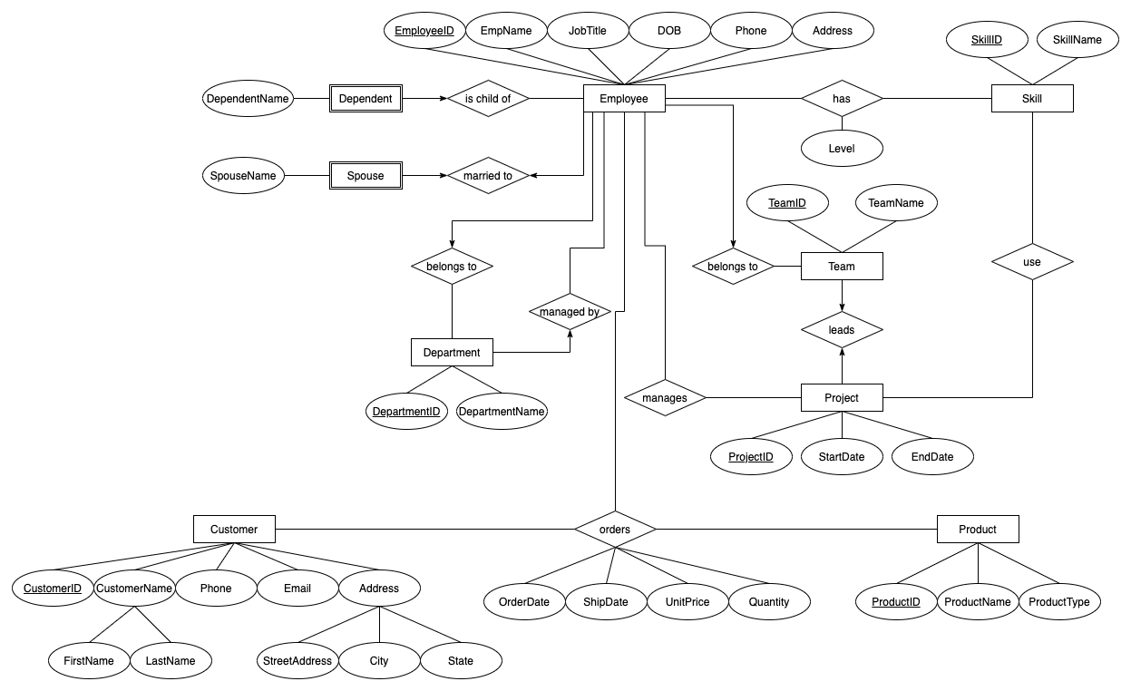

PDM：
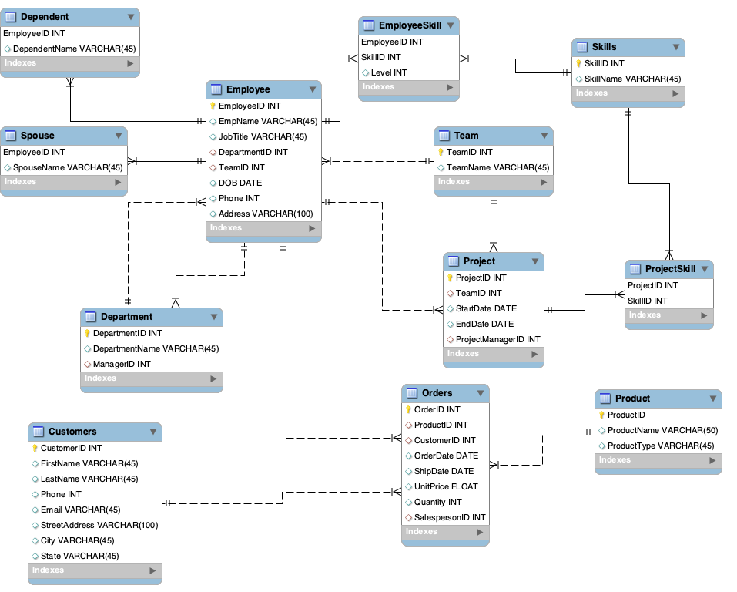

SQL：
-- -----------------------------------------------------
-- Schema CaseStudy
-- -----------------------------------------------------
CREATE SCHEMA IF NOT EXISTS `CaseStudy` DEFAULT CHARACTER SET utf8 ;
USE `CaseStudy` ;

-- -----------------------------------------------------
-- Table `CaseStudy`.`Department`
-- -----------------------------------------------------
CREATE TABLE IF NOT EXISTS `CaseStudy`.`Department` (
`DepartmentID` INT NOT NULL,
`DepartmentName` VARCHAR(45) NULL,
`ManagerID` INT NULL,
PRIMARY KEY (`DepartmentID`),
INDEX `fk_Department_Employee_idx` (`ManagerID` ASC) VISIBLE,
CONSTRAINT `fk_Department_Employee`
FOREIGN KEY (`ManagerID`)
REFERENCES `CaseStudy`.`Employee` (`EmployeeID`)
ON DELETE NO ACTION
ON UPDATE NO ACTION)
ENGINE = InnoDB;

-- -----------------------------------------------------
-- Table `CaseStudy`.`Team`
-- -----------------------------------------------------
CREATE TABLE IF NOT EXISTS `CaseStudy`.`Team` (
`TeamID` INT NOT NULL,
`TeamName` VARCHAR(45) NULL,
PRIMARY KEY (`TeamID`))
ENGINE = InnoDB;

`DOB` DATE NULL,
`Phone` INT NULL,
`Address` VARCHAR(100) NULL,
PRIMARY KEY (`EmployeeID`),
INDEX `fk_Employee_Department1_idx` (`DepartmentID` ASC) VISIBLE,
INDEX `fk_Employee_Team1_idx` (`TeamID` ASC) VISIBLE,
CONSTRAINT `fk_Employee_Department1`
FOREIGN KEY (`DepartmentID`)
REFERENCES `CaseStudy`.`Department` (`DepartmentID`)
ON DELETE NO ACTION
ON UPDATE NO ACTION,
CONSTRAINT `fk_Employee_Team1`
FOREIGN KEY (`TeamID`)
REFERENCES `CaseStudy`.`Team` (`TeamID`)
ON DELETE NO ACTION
ON UPDATE NO ACTION)
ENGINE = InnoDB;

-- -----------------------------------------------------
-- Table `CaseStudy`.`Product`
-- -----------------------------------------------------
CREATE TABLE IF NOT EXISTS `CaseStudy`.`Product` (
`ProductID` INT NOT NULL,
`ProductName` VARCHAR(50) NULL,
`ProductType` VARCHAR(45) NULL,
PRIMARY KEY (`ProductID`))
ENGINE = InnoDB;

-- -----------------------------------------------------
-- Table `CaseStudy`.`Project`
-- -----------------------------------------------------
CREATE TABLE IF NOT EXISTS `CaseStudy`.`Project` (
`ProjectID` INT NOT NULL,
`TeamID` INT NULL,
`StartDate` DATE NULL,
`EndDate` DATE NULL,
`ProjectManagerID` INT NULL,
PRIMARY KEY (`ProjectID`),
INDEX `fk_Project_Team1_idx` (`TeamID` ASC) VISIBLE,
INDEX `fk_Project_Employee1_idx` (`ProjectManagerID` ASC) VISIBLE,
CONSTRAINT `fk_Project_Team1`
FOREIGN KEY (`TeamID`)
REFERENCES `CaseStudy`.`Team` (`TeamID`)
ON DELETE NO ACTION
ON UPDATE NO ACTION,
CONSTRAINT `fk_Project_Employee1`
FOREIGN KEY (`ProjectManagerID`)
REFERENCES `CaseStudy`.`Employee` (`EmployeeID`)
ON DELETE NO ACTION
ON UPDATE NO ACTION)
ENGINE = InnoDB;

-- -----------------------------------------------------
-- Table `CaseStudy`.`Dependent`
-- -----------------------------------------------------
CREATE TABLE IF NOT EXISTS `CaseStudy`.`Dependent` (
`EmployeeID` INT NOT NULL,
`DependentName` VARCHAR(45) NULL,
PRIMARY KEY (`EmployeeID`),
CONSTRAINT `fk_Dependent_Employee1`
FOREIGN KEY (`EmployeeID`)
REFERENCES `CaseStudy`.`Employee` (`EmployeeID`)
ON DELETE NO ACTION
ON UPDATE NO ACTION)
ENGINE = InnoDB;

-- -----------------------------------------------------
-- Table `CaseStudy`.`Skills`
-- -----------------------------------------------------
CREATE TABLE IF NOT EXISTS `CaseStudy`.`Skills` (
`SkillID` INT NOT NULL,
`SkillName` VARCHAR(45) NULL,
PRIMARY KEY (`SkillID`))
ENGINE = InnoDB;

-- -----------------------------------------------------
-- Table `CaseStudy`.`EmployeeSkill`
-- -----------------------------------------------------
CREATE TABLE IF NOT EXISTS `CaseStudy`.`EmployeeSkill` (
`EmployeeID` INT NOT NULL,
`SkillID` INT NOT NULL,
`Level` INT NULL,
PRIMARY KEY (`EmployeeID`, `SkillID`),
INDEX `fk_EmployeeSkill_Skills1_idx` (`SkillID` ASC) VISIBLE,
CONSTRAINT `fk_EmployeeSkill_Employee1`
FOREIGN KEY (`EmployeeID`)
REFERENCES `CaseStudy`.`Employee` (`EmployeeID`)
ON DELETE NO ACTION
ON UPDATE NO ACTION,
CONSTRAINT `fk_EmployeeSkill_Skills1`
FOREIGN KEY (`SkillID`)
REFERENCES `CaseStudy`.`Skills` (`SkillID`)
ON DELETE NO ACTION
ON UPDATE NO ACTION)
ENGINE = InnoDB;

-- -----------------------------------------------------
-- Table `CaseStudy`.`EmployeeSkill_copy1`
-- -----------------------------------------------------
CREATE TABLE IF NOT EXISTS `CaseStudy`.`EmployeeSkill_copy1` (
`EmployeeID` INT NOT NULL,
`SkillID` INT NOT NULL,
`Level` INT NULL,
PRIMARY KEY (`EmployeeID`, `SkillID`),
INDEX `fk_EmployeeSkill_Skills1_idx` (`SkillID` ASC) VISIBLE,
CONSTRAINT `fk_EmployeeSkill_Employee10`
FOREIGN KEY (`EmployeeID`)
REFERENCES `CaseStudy`.`Employee` (`EmployeeID`)
ON DELETE NO ACTION
ON UPDATE NO ACTION,
CONSTRAINT `fk_EmployeeSkill_Skills10`
FOREIGN KEY (`SkillID`)
REFERENCES `CaseStudy`.`Skills` (`SkillID`)
ON DELETE NO ACTION
ON UPDATE NO ACTION)
ENGINE = InnoDB;

-- -----------------------------------------------------
-- Table `CaseStudy`.`ProjectSkill`
-- -----------------------------------------------------
CREATE TABLE IF NOT EXISTS `CaseStudy`.`ProjectSkill` (
`ProjectID` INT NOT NULL,
`SkillID` INT NOT NULL,
PRIMARY KEY (`ProjectID`, `SkillID`),
INDEX `fk_ProjectSkill_Skills1_idx` (`SkillID` ASC) VISIBLE,
CONSTRAINT `fk_ProjectSkill_Project1`
FOREIGN KEY (`ProjectID`)
REFERENCES `CaseStudy`.`Project` (`ProjectID`)
ON DELETE NO ACTION
ON UPDATE NO ACTION,
CONSTRAINT `fk_ProjectSkill_Skills1`
FOREIGN KEY (`SkillID`)
REFERENCES `CaseStudy`.`Skills` (`SkillID`)
ON DELETE NO ACTION
ON UPDATE NO ACTION)
ENGINE = InnoDB;

-- -----------------------------------------------------
-- Table `CaseStudy`.`Customers`
-- -----------------------------------------------------
CREATE TABLE IF NOT EXISTS `CaseStudy`.`Customers` (
`CustomerID` INT NOT NULL,
`FirstName` VARCHAR(45) NULL,
`LastName` VARCHAR(45) NULL,
`Phone` INT NULL,
`Email` VARCHAR(45) NULL,
`StreetAddress` VARCHAR(100) NULL,
`City` VARCHAR(45) NULL,
`State` VARCHAR(45) NULL,
PRIMARY KEY (`CustomerID`))
ENGINE = InnoDB;

-- -----------------------------------------------------
-- Table `CaseStudy`.`Spouse`
-- -----------------------------------------------------
CREATE TABLE IF NOT EXISTS `CaseStudy`.`Spouse` (
`EmployeeID` INT NOT NULL,
`SpouseName` VARCHAR(45) NULL,
PRIMARY KEY (`EmployeeID`),
CONSTRAINT `fk_Spouse_Employee1`
FOREIGN KEY (`EmployeeID`)
REFERENCES `CaseStudy`.`Employee` (`EmployeeID`)
ON DELETE NO ACTION
ON UPDATE NO ACTION)
ENGINE = InnoDB;

-- -----------------------------------------------------
-- Table `CaseStudy`.`Orders`
-- -----------------------------------------------------
CREATE TABLE IF NOT EXISTS `CaseStudy`.`Orders` (
`OrderID` INT NOT NULL,
`ProductID` INT NULL,
`CustomerID` INT NULL,
`OrderDate` DATE NULL,
`ShipDate` DATE NULL,
`UnitPrice` FLOAT NULL,
`Quantity` INT NULL,
`SalespersonID` INT NULL,
PRIMARY KEY (`OrderID`),
INDEX `fk_Orders_Customers1_idx` (`CustomerID` ASC) VISIBLE,
INDEX `fk_Orders_Product1_idx` (`ProductID` ASC) VISIBLE,
INDEX `fk_Orders_Employee1_idx` (`SalespersonID` ASC) VISIBLE,
CONSTRAINT `fk_Orders_Customers1`
FOREIGN KEY (`CustomerID`)
REFERENCES `CaseStudy`.`Customers` (`CustomerID`)
ON DELETE NO ACTION
ON UPDATE NO ACTION,
CONSTRAINT `fk_Orders_Product1`
FOREIGN KEY (`ProductID`)
REFERENCES `CaseStudy`.`Product` (`ProductID`)
ON DELETE NO ACTION
ON UPDATE NO ACTION,
CONSTRAINT `fk_Orders_Employee1`
FOREIGN KEY (`SalespersonID`)
REFERENCES `CaseStudy`.`Employee` (`EmployeeID`)
ON DELETE NO ACTION
ON UPDATE NO ACTION)
ENGINE = InnoDB;

-- -----------------------------------------------------
-- Table `CaseStudy`.`Employee`
-- -----------------------------------------------------
CREATE TABLE IF NOT EXISTS `CaseStudy`.`Employee` (
`EmployeeID` INT NOT NULL,
`EmpName` VARCHAR(45) NULL,
`JobTitle` VARCHAR(45) NULL,
`DepartmentID` INT NULL,
`TeamID` INT NULL,
`DOB` DATE NULL,
`Phone` INT NULL,
`Address` VARCHAR(100) NULL,
PRIMARY KEY (`EmployeeID`),
INDEX `fk_Employee_Department1_idx` (`DepartmentID` ASC) VISIBLE,
INDEX `fk_Employee_Team1_idx` (`TeamID` ASC) VISIBLE,
CONSTRAINT `fk_Employee_Department1`
FOREIGN KEY (`DepartmentID`)
REFERENCES `CaseStudy`.`Department` (`DepartmentID`)
ON DELETE NO ACTION
ON UPDATE NO ACTION,
CONSTRAINT `fk_Employee_Team1`
FOREIGN KEY (`TeamID`)
REFERENCES `CaseStudy`.`Team` (`TeamID`)
ON DELETE NO ACTION
ON UPDATE NO ACTION)
ENGINE = InnoDB;
-- -----------------------------------------------------
-- Table `CaseStudy`.`Product`
-- -----------------------------------------------------
CREATE TABLE IF NOT EXISTS `CaseStudy`.`Product` (
`ProductID` INT NOT NULL,
`ProductName` VARCHAR(50) NULL,
`ProductType` VARCHAR(45) NULL,
PRIMARY KEY (`ProductID`))
ENGINE = InnoDB;
-- -----------------------------------------------------
-- Table `CaseStudy`.`Project`
-- -----------------------------------------------------
CREATE TABLE IF NOT EXISTS `CaseStudy`.`Project` (
`ProjectID` INT NOT NULL,
`TeamID` INT NULL,
`StartDate` DATE NULL,
`EndDate` DATE NULL,
`ProjectManagerID` INT NULL,
PRIMARY KEY (`ProjectID`),
INDEX `fk_Project_Team1_idx` (`TeamID` ASC) VISIBLE,
INDEX `fk_Project_Employee1_idx` (`ProjectManagerID` ASC) VISIBLE,
CONSTRAINT `fk_Project_Team1`
FOREIGN KEY (`TeamID`)
REFERENCES `CaseStudy`.`Team` (`TeamID`)
ON DELETE NO ACTION
ON UPDATE NO ACTION,
CONSTRAINT `fk_Project_Employee1`
FOREIGN KEY (`ProjectManagerID`)
REFERENCES `CaseStudy`.`Employee` (`EmployeeID`)
ON DELETE NO ACTION
ON UPDATE NO ACTION)
ENGINE = InnoDB;

-- -----------------------------------------------------
-- Table `CaseStudy`.`Dependent`
-- -----------------------------------------------------
CREATE TABLE IF NOT EXISTS `CaseStudy`.`Dependent` (
`EmployeeID` INT NOT NULL,
`DependentName` VARCHAR(45) NULL,
PRIMARY KEY (`EmployeeID`),
CONSTRAINT `fk_Dependent_Employee1`
FOREIGN KEY (`EmployeeID`)
REFERENCES `CaseStudy`.`Employee` (`EmployeeID`)
ON DELETE NO ACTION
ON UPDATE NO ACTION)
ENGINE = InnoDB;

-- -----------------------------------------------------
-- Table `CaseStudy`.`Skills`
-- -----------------------------------------------------
CREATE TABLE IF NOT EXISTS `CaseStudy`.`Skills` (
`SkillID` INT NOT NULL,
`SkillName` VARCHAR(45) NULL,
PRIMARY KEY (`SkillID`))
ENGINE = InnoDB;

-- -----------------------------------------------------
-- Table `CaseStudy`.`EmployeeSkill`
-- -----------------------------------------------------
CREATE TABLE IF NOT EXISTS `CaseStudy`.`EmployeeSkill` (
`EmployeeID` INT NOT NULL,
`SkillID` INT NOT NULL,
`Level` INT NULL,
PRIMARY KEY (`EmployeeID`, `SkillID`),
INDEX `fk_EmployeeSkill_Skills1_idx` (`SkillID` ASC) VISIBLE,
CONSTRAINT `fk_EmployeeSkill_Employee1`
FOREIGN KEY (`EmployeeID`)
REFERENCES `CaseStudy`.`Employee` (`EmployeeID`)
ON DELETE NO ACTION
ON UPDATE NO ACTION,
CONSTRAINT `fk_EmployeeSkill_Skills1`
FOREIGN KEY (`SkillID`)
REFERENCES `CaseStudy`.`Skills` (`SkillID`)
ON DELETE NO ACTION
ON UPDATE NO ACTION)
ENGINE = InnoDB;

-- -----------------------------------------------------
-- Table `CaseStudy`.`EmployeeSkill_copy1`
-- -----------------------------------------------------
CREATE TABLE IF NOT EXISTS `CaseStudy`.`EmployeeSkill_copy1` (
`EmployeeID` INT NOT NULL,
`SkillID` INT NOT NULL,
`Level` INT NULL,
PRIMARY KEY (`EmployeeID`, `SkillID`),
INDEX `fk_EmployeeSkill_Skills1_idx` (`SkillID` ASC) VISIBLE,
CONSTRAINT `fk_EmployeeSkill_Employee10`
FOREIGN KEY (`EmployeeID`)
REFERENCES `CaseStudy`.`Employee` (`EmployeeID`)
ON DELETE NO ACTION
ON UPDATE NO ACTION,
CONSTRAINT `fk_EmployeeSkill_Skills10`
FOREIGN KEY (`SkillID`)
REFERENCES `CaseStudy`.`Skills` (`SkillID`)
ON DELETE NO ACTION
ON UPDATE NO ACTION)
ENGINE = InnoDB;

-- -----------------------------------------------------
-- Table `CaseStudy`.`ProjectSkill`
-- -----------------------------------------------------
CREATE TABLE IF NOT EXISTS `CaseStudy`.`ProjectSkill` (
`ProjectID` INT NOT NULL,
`SkillID` INT NOT NULL,
PRIMARY KEY (`ProjectID`, `SkillID`),
INDEX `fk_ProjectSkill_Skills1_idx` (`SkillID` ASC) VISIBLE,
CONSTRAINT `fk_ProjectSkill_Project1`
FOREIGN KEY (`ProjectID`)
REFERENCES `CaseStudy`.`Project` (`ProjectID`)
ON DELETE NO ACTION
ON UPDATE NO ACTION,
CONSTRAINT `fk_ProjectSkill_Skills1`
FOREIGN KEY (`SkillID`)
REFERENCES `CaseStudy`.`Skills` (`SkillID`)
ON DELETE NO ACTION
ON UPDATE NO ACTION)
ENGINE = InnoDB;

-- -----------------------------------------------------
-- Table `CaseStudy`.`Customers`
-- -----------------------------------------------------
CREATE TABLE IF NOT EXISTS `CaseStudy`.`Customers` (
`CustomerID` INT NOT NULL,
`FirstName` VARCHAR(45) NULL,
`LastName` VARCHAR(45) NULL,
`Phone` INT NULL,
`Email` VARCHAR(45) NULL,
`StreetAddress` VARCHAR(100) NULL,
`City` VARCHAR(45) NULL,
`State` VARCHAR(45) NULL,
PRIMARY KEY (`CustomerID`))
ENGINE = InnoDB;

-- -----------------------------------------------------
-- Table `CaseStudy`.`Spouse`
-- -----------------------------------------------------
CREATE TABLE IF NOT EXISTS `CaseStudy`.`Spouse` (
`EmployeeID` INT NOT NULL,
`SpouseName` VARCHAR(45) NULL,
PRIMARY KEY (`EmployeeID`),
CONSTRAINT `fk_Spouse_Employee1`
FOREIGN KEY (`EmployeeID`)
REFERENCES `CaseStudy`.`Employee` (`EmployeeID`)
ON DELETE NO ACTION
ON UPDATE NO ACTION)
ENGINE = InnoDB;

-- -----------------------------------------------------
-- Table `CaseStudy`.`Orders`
-- -----------------------------------------------------
CREATE TABLE IF NOT EXISTS `CaseStudy`.`Orders` (
`OrderID` INT NOT NULL,
`ProductID` INT NULL,
`CustomerID` INT NULL,
`OrderDate` DATE NULL,
`ShipDate` DATE NULL,
`UnitPrice` FLOAT NULL,
`Quantity` INT NULL,
`SalespersonID` INT NULL,
PRIMARY KEY (`OrderID`),
INDEX `fk_Orders_Customers1_idx` (`CustomerID` ASC) VISIBLE,
INDEX `fk_Orders_Product1_idx` (`ProductID` ASC) VISIBLE,
INDEX `fk_Orders_Employee1_idx` (`SalespersonID` ASC) VISIBLE,
CONSTRAINT `fk_Orders_Customers1`
FOREIGN KEY (`CustomerID`)
REFERENCES `CaseStudy`.`Customers` (`CustomerID`)
ON DELETE NO ACTION
ON UPDATE NO ACTION,
CONSTRAINT `fk_Orders_Product1`
FOREIGN KEY (`ProductID`)
REFERENCES `CaseStudy`.`Product` (`ProductID`)
ON DELETE NO ACTION
ON UPDATE NO ACTION,
CONSTRAINT `fk_Orders_Employee1`
FOREIGN KEY (`SalespersonID`)
REFERENCES `CaseStudy`.`Employee` (`EmployeeID`)
ON DELETE NO ACTION
ON UPDATE NO ACTION)
ENGINE = InnoDB;

`ProjectManagerID` INT NULL,
PRIMARY KEY (`ProjectID`),
INDEX `fk_Project_Team1_idx` (`TeamID` ASC) VISIBLE,
INDEX `fk_Project_Employee1_idx` (`ProjectManagerID` ASC) VISIBLE,
CONSTRAINT `fk_Project_Team1`
FOREIGN KEY (`TeamID`)
REFERENCES `CaseStudy`.`Team` (`TeamID`)
ON DELETE NO ACTION
ON UPDATE NO ACTION,
CONSTRAINT `fk_Project_Employee1`
FOREIGN KEY (`ProjectManagerID`)
REFERENCES `CaseStudy`.`Employee` (`EmployeeID`)
ON DELETE NO ACTION
ON UPDATE NO ACTION)
ENGINE = InnoDB;
-- -----------------------------------------------------
-- Table `CaseStudy`.`Dependent`
-- -----------------------------------------------------
CREATE TABLE IF NOT EXISTS `CaseStudy`.`Dependent` (
`EmployeeID` INT NOT NULL,
`DependentName` VARCHAR(45) NULL,
PRIMARY KEY (`EmployeeID`),
CONSTRAINT `fk_Dependent_Employee1`
FOREIGN KEY (`EmployeeID`)
REFERENCES `CaseStudy`.`Employee` (`EmployeeID`)
ON DELETE NO ACTION
ON UPDATE NO ACTION)
ENGINE = InnoDB;
-- -----------------------------------------------------
-- Table `CaseStudy`.`Skills`
-- -----------------------------------------------------
CREATE TABLE IF NOT EXISTS `CaseStudy`.`Skills` (
`SkillID` INT NOT NULL,
`SkillName` VARCHAR(45) NULL,
PRIMARY KEY (`SkillID`))
ENGINE = InnoDB;
-- -----------------------------------------------------
-- Table `CaseStudy`.`EmployeeSkill`
-- -----------------------------------------------------
CREATE TABLE IF NOT EXISTS `CaseStudy`.`EmployeeSkill` (
`EmployeeID` INT NOT NULL,
`SkillID` INT NOT NULL,
`Level` INT NULL,
PRIMARY KEY (`EmployeeID`, `SkillID`),
INDEX `fk_EmployeeSkill_Skills1_idx` (`SkillID` ASC) VISIBLE,
CONSTRAINT `fk_EmployeeSkill_Employee1`
FOREIGN KEY (`EmployeeID`)
REFERENCES `CaseStudy`.`Employee` (`EmployeeID`)
ON DELETE NO ACTION
ON UPDATE NO ACTION,
CONSTRAINT `fk_EmployeeSkill_Skills1`
FOREIGN KEY (`SkillID`)
REFERENCES `CaseStudy`.`Skills` (`SkillID`)
ON DELETE NO ACTION
ON UPDATE NO ACTION)
ENGINE = InnoDB;

-- -----------------------------------------------------
-- Table `CaseStudy`.`EmployeeSkill_copy1`
-- -----------------------------------------------------
CREATE TABLE IF NOT EXISTS `CaseStudy`.`EmployeeSkill_copy1` (
`EmployeeID` INT NOT NULL,
`SkillID` INT NOT NULL,
`Level` INT NULL,
PRIMARY KEY (`EmployeeID`, `SkillID`),
INDEX `fk_EmployeeSkill_Skills1_idx` (`SkillID` ASC) VISIBLE,
CONSTRAINT `fk_EmployeeSkill_Employee10`
FOREIGN KEY (`EmployeeID`)
REFERENCES `CaseStudy`.`Employee` (`EmployeeID`)
ON DELETE NO ACTION
ON UPDATE NO ACTION,
CONSTRAINT `fk_EmployeeSkill_Skills10`
FOREIGN KEY (`SkillID`)
REFERENCES `CaseStudy`.`Skills` (`SkillID`)
ON DELETE NO ACTION
ON UPDATE NO ACTION)
ENGINE = InnoDB;

-- -----------------------------------------------------
-- Table `CaseStudy`.`ProjectSkill`
-- -----------------------------------------------------
CREATE TABLE IF NOT EXISTS `CaseStudy`.`ProjectSkill` (
`ProjectID` INT NOT NULL,
`SkillID` INT NOT NULL,
PRIMARY KEY (`ProjectID`, `SkillID`),
INDEX `fk_ProjectSkill_Skills1_idx` (`SkillID` ASC) VISIBLE,
CONSTRAINT `fk_ProjectSkill_Project1`
FOREIGN KEY (`ProjectID`)
REFERENCES `CaseStudy`.`Project` (`ProjectID`)
ON DELETE NO ACTION
ON UPDATE NO ACTION,
CONSTRAINT `fk_ProjectSkill_Skills1`
FOREIGN KEY (`SkillID`)
REFERENCES `CaseStudy`.`Skills` (`SkillID`)
ON DELETE NO ACTION
ON UPDATE NO ACTION)
ENGINE = InnoDB;

-- -----------------------------------------------------
-- Table `CaseStudy`.`Customers`
-- -----------------------------------------------------
CREATE TABLE IF NOT EXISTS `CaseStudy`.`Customers` (
`CustomerID` INT NOT NULL,
`FirstName` VARCHAR(45) NULL,
`LastName` VARCHAR(45) NULL,
`Phone` INT NULL,
`Email` VARCHAR(45) NULL,
`StreetAddress` VARCHAR(100) NULL,
`City` VARCHAR(45) NULL,
`State` VARCHAR(45) NULL,
PRIMARY KEY (`CustomerID`))
ENGINE = InnoDB;

-- -----------------------------------------------------
-- Table `CaseStudy`.`Spouse`
-- -----------------------------------------------------
CREATE TABLE IF NOT EXISTS `CaseStudy`.`Spouse` (
`EmployeeID` INT NOT NULL,
`SpouseName` VARCHAR(45) NULL,
PRIMARY KEY (`EmployeeID`),
CONSTRAINT `fk_Spouse_Employee1`
FOREIGN KEY (`EmployeeID`)
REFERENCES `CaseStudy`.`Employee` (`EmployeeID`)
ON DELETE NO ACTION
ON UPDATE NO ACTION)
ENGINE = InnoDB;

PRIMARY KEY (`EmployeeID`, `SkillID`),
INDEX `fk_EmployeeSkill_Skills1_idx` (`SkillID` ASC) VISIBLE,
CONSTRAINT `fk_EmployeeSkill_Employee1`
FOREIGN KEY (`EmployeeID`)
REFERENCES `CaseStudy`.`Employee` (`EmployeeID`)
ON DELETE NO ACTION
ON UPDATE NO ACTION,
CONSTRAINT `fk_EmployeeSkill_Skills1`
FOREIGN KEY (`SkillID`)
REFERENCES `CaseStudy`.`Skills` (`SkillID`)
ON DELETE NO ACTION
ON UPDATE NO ACTION)
ENGINE = InnoDB;
-- -----------------------------------------------------
-- Table `CaseStudy`.`EmployeeSkill_copy1`
-- -----------------------------------------------------
CREATE TABLE IF NOT EXISTS `CaseStudy`.`EmployeeSkill_copy1` (
`EmployeeID` INT NOT NULL,
`SkillID` INT NOT NULL,
`Level` INT NULL,
PRIMARY KEY (`EmployeeID`, `SkillID`),
INDEX `fk_EmployeeSkill_Skills1_idx` (`SkillID` ASC) VISIBLE,
CONSTRAINT `fk_EmployeeSkill_Employee10`
FOREIGN KEY (`EmployeeID`)
REFERENCES `CaseStudy`.`Employee` (`EmployeeID`)
ON DELETE NO ACTION
ON UPDATE NO ACTION,
CONSTRAINT `fk_EmployeeSkill_Skills10`
FOREIGN KEY (`SkillID`)
REFERENCES `CaseStudy`.`Skills` (`SkillID`)
ON DELETE NO ACTION
ON UPDATE NO ACTION)
ENGINE = InnoDB;
-- -----------------------------------------------------
-- Table `CaseStudy`.`ProjectSkill`
-- -----------------------------------------------------
CREATE TABLE IF NOT EXISTS `CaseStudy`.`ProjectSkill` (
`ProjectID` INT NOT NULL,
`SkillID` INT NOT NULL,
PRIMARY KEY (`ProjectID`, `SkillID`),
INDEX `fk_ProjectSkill_Skills1_idx` (`SkillID` ASC) VISIBLE,
CONSTRAINT `fk_ProjectSkill_Project1`
FOREIGN KEY (`ProjectID`)
REFERENCES `CaseStudy`.`Project` (`ProjectID`)
ON DELETE NO ACTION
ON UPDATE NO ACTION,
CONSTRAINT `fk_ProjectSkill_Skills1`
FOREIGN KEY (`SkillID`)
REFERENCES `CaseStudy`.`Skills` (`SkillID`)
ON DELETE NO ACTION
ON UPDATE NO ACTION)
ENGINE = InnoDB;

-- -----------------------------------------------------
-- Table `CaseStudy`.`Customers`
-- -----------------------------------------------------
CREATE TABLE IF NOT EXISTS `CaseStudy`.`Customers` (
`CustomerID` INT NOT NULL,
`FirstName` VARCHAR(45) NULL,
`LastName` VARCHAR(45) NULL,
`Phone` INT NULL,
`Email` VARCHAR(45) NULL,
`StreetAddress` VARCHAR(100) NULL,
`City` VARCHAR(45) NULL,
`State` VARCHAR(45) NULL,
PRIMARY KEY (`CustomerID`))
ENGINE = InnoDB;

-- -----------------------------------------------------
-- Table `CaseStudy`.`Spouse`
-- -----------------------------------------------------
CREATE TABLE IF NOT EXISTS `CaseStudy`.`Spouse` (
`EmployeeID` INT NOT NULL,
`SpouseName` VARCHAR(45) NULL,
PRIMARY KEY (`EmployeeID`),
CONSTRAINT `fk_Spouse_Employee1`
FOREIGN KEY (`EmployeeID`)
REFERENCES `CaseStudy`.`Employee` (`EmployeeID`)
ON DELETE NO ACTION
ON UPDATE NO ACTION)
ENGINE = InnoDB;

ON DELETE NO ACTION
ON UPDATE NO ACTION,
CONSTRAINT `fk_ProjectSkill_Skills1`
FOREIGN KEY (`SkillID`)
REFERENCES `CaseStudy`.`Skills` (`SkillID`)
ON DELETE NO ACTION
ON UPDATE NO ACTION)
ENGINE = InnoDB;
-- -----------------------------------------------------
-- Table `CaseStudy`.`Customers`
-- -----------------------------------------------------
CREATE TABLE IF NOT EXISTS `CaseStudy`.`Customers` (
`CustomerID` INT NOT NULL,
`FirstName` VARCHAR(45) NULL,
`LastName` VARCHAR(45) NULL,
`Phone` INT NULL,
`Email` VARCHAR(45) NULL,
`StreetAddress` VARCHAR(100) NULL,
`City` VARCHAR(45) NULL,
`State` VARCHAR(45) NULL,
PRIMARY KEY (`CustomerID`))
ENGINE = InnoDB;
-- -----------------------------------------------------
-- Table `CaseStudy`.`Spouse`
-- -----------------------------------------------------
CREATE TABLE IF NOT EXISTS `CaseStudy`.`Spouse` (
`EmployeeID` INT NOT NULL,
`SpouseName` VARCHAR(45) NULL,
PRIMARY KEY (`EmployeeID`),
CONSTRAINT `fk_Spouse_Employee1`
FOREIGN KEY (`EmployeeID`)
REFERENCES `CaseStudy`.`Employee` (`EmployeeID`)
ON DELETE NO ACTION
ON UPDATE NO ACTION)
ENGINE = InnoDB;
-- -----------------------------------------------------
-- Table `CaseStudy`.`Orders`
-- -----------------------------------------------------
CREATE TABLE IF NOT EXISTS `CaseStudy`.`Orders` (
`OrderID` INT NOT NULL,
`ProductID` INT NULL,
`CustomerID` INT NULL,
`OrderDate` DATE NULL,
`ShipDate` DATE NULL,
`UnitPrice` FLOAT NULL,
`Quantity` INT NULL,
`SalespersonID` INT NULL,
PRIMARY KEY (`OrderID`),
INDEX `fk_Orders_Customers1_idx` (`CustomerID` ASC) VISIBLE,
INDEX `fk_Orders_Product1_idx` (`ProductID` ASC) VISIBLE,
INDEX `fk_Orders_Employee1_idx` (`SalespersonID` ASC) VISIBLE,
CONSTRAINT `fk_Orders_Customers1`
FOREIGN KEY (`CustomerID`)
REFERENCES `CaseStudy`.`Customers` (`CustomerID`)
ON DELETE NO ACTION
ON UPDATE NO ACTION,
CONSTRAINT `fk_Orders_Product1`
FOREIGN KEY (`ProductID`)
REFERENCES `CaseStudy`.`Product` (`ProductID`)
ON DELETE NO ACTION
ON UPDATE NO ACTION,
CONSTRAINT `fk_Orders_Employee1`
FOREIGN KEY (`SalespersonID`)
REFERENCES `CaseStudy`.`Employee` (`EmployeeID`)
ON DELETE NO ACTION
ON UPDATE NO ACTION)
ENGINE = InnoDB;

`ShipDate` DATE NULL,
`UnitPrice` FLOAT NULL,
`Quantity` INT NULL,
`SalespersonID` INT NULL,
PRIMARY KEY (`OrderID`),
INDEX `fk_Orders_Customers1_idx` (`CustomerID` ASC) VISIBLE,
INDEX `fk_Orders_Product1_idx` (`ProductID` ASC) VISIBLE,
INDEX `fk_Orders_Employee1_idx` (`SalespersonID` ASC) VISIBLE,
CONSTRAINT `fk_Orders_Customers1`
FOREIGN KEY (`CustomerID`)
REFERENCES `CaseStudy`.`Customers` (`CustomerID`)
ON DELETE NO ACTION
ON UPDATE NO ACTION,
CONSTRAINT `fk_Orders_Product1`
FOREIGN KEY (`ProductID`)
REFERENCES `CaseStudy`.`Product` (`ProductID`)
ON DELETE NO ACTION
ON UPDATE NO ACTION,
CONSTRAINT `fk_Orders_Employee1`
FOREIGN KEY (`SalespersonID`)
REFERENCES `CaseStudy`.`Employee` (`EmployeeID`)
ON DELETE NO ACTION
ON UPDATE NO ACTION)
ENGINE = InnoDB;

深圳大学学生实验报告用纸

指导教师批阅意见：

成绩评定：

指导教师签字：Basker George
2019年12月 04 日
备注：
注：1、报告内的项目或内容设置，可根据实际情况加以调整和补充。
2、教师批改学生实验报告时间应在学生提交实验报告时间后10日内。

